Ref: TMT/Ernakulam/S0724/2026 28-03-2026

To
Ernakulam,
Mobile: 7972726191.

Dear sir,

Sub: SUPPLY OF ROLL FORMING MACHINES FOR FALSE CEILING SECTIONS
Thank you very much for your enquiry regarding your requirement of roll forming machine mainly for GI sections. We are glad to inform you that we would be in a position to supply you the required equipment in five different machines for five sections. Given below are the required specifications and description of the machines and our terms and conditions.

PRICE

- Price for the below list of machinery is Rs 15,00,000/-
- Tooling 4 sections Ceiling, Intermediate, perimeter, and
L Angle sections Rs 2,40,000/-
- Cutting tooling 4 sections Rs 3,30,000/-
- Ultra roll station Rs 2,00,000/-
- Commercial sections 2 no’s including cutting tools
Ceiling section: : Rs 55,000/-
Cutoff tool: : Rs 25,000/-
Intermediate: Rs 30000/-
Cutoff tool: : Rs 20,000/-
Total machine with 5 sets of tooling: 24.00.000/-

LIST OF MACHINERY

MILL: 300 mm WIDE ROLL FORMING MILL1

DE COILER 1.0 MT CAPACITY
- 10 STATION ROLL FORMING MACHINE-1 NOS
- POWER PACK 5 HP
- 12 FEET RUNOUT TABLE
- ELECTRICAL PANEL WITH SPEED VARIATION

Description of the equipment

Roll Forming Machine
Main Base
The main base is MS fabricated structure and adequately ribbed to minimize the distortion. It is accurately machined on top and bottom surfaces the threaded holes are made on the bed for positioning the stands.
Entry Guide
The entry side of the machine will be equipped with guide table and the guide wheels bar which will be responsible for centering the leading ends of the strip into the first pass.
Mill stands
The stands are mounted on the bed of the machine the line alignment can be easily done due to guide ways arranged on the bed of the machine. Each forming head consists of a fixed housing and sliding type out board housing. The mill stands will be arranged to locate shafts mounted on anti-friction bearings. For the top shafts the bearings are housed in the cartridge type bearing blocks. The bottom shaft bearings are located in the bored machined in the housings. The bottom arbors are fixed in position whereas the top arbors along with cartridge blocks could be raised or lowered in vertical guides machined in housings.
Roll shafts
The roll shafts will be manufactured from quality steel and will be keyed to locate tooling.
Drive
The drive to the roll former will be by means of a gear box system. The main drive will be provided by means of 7.5 HP motor. The speed of the roll former is fixed.

Delivery runout table
The delivery runout table is with four meters length.
Cutoff unit
The cutoff unit with hydraulic press along with cutting die set will be placed in the machine delivery side.
- GENERAL TERMS & CONDITIONS:

1 Price quoted per unit ex-work. Hyderabad.
2 Following charges are additional to your account.
- Freight Charge : As actual to be borne by you.
- Sales Tax : 18% GST
- Packing charge : As actual to be borne by you.
- Insurance : As actual to be borne by you.
3Payment : 50% advance alongwith order another 25%
advance after 3 weeks from first advance and
balance before delivery but after inspection at our
works.
- Delivery : 6-8 weeks from date of techno-commercially clear
purchase order.
- Validity : One month from the date of submission.
- Inspection : Inspection at our works prior to dispatch.
- Warranty : The machine is warranted for a period of 12
months from the date of dispatch against any
manufacturing defects/faulty material or bad
workmanship of any part or component but not
against any kind of abnormal or improper use of
machine. Defective part or component will be
replaced or repaired free of cost. Electrical
components are outside the scope of this
warranty.
- Commissioning : Erection & commissioning done by you, but if
required technical support & guidance provide by
us at additional cost.

NOTE:
- Oil is not in scope of our supply.
- Raw material for trial is arrange by you at your cost.

We are sure you will find our offer in line with your requirements. Should you require any further clarification please call us on mobile number 9246221106.

Thanking you and assuring you of our best services.

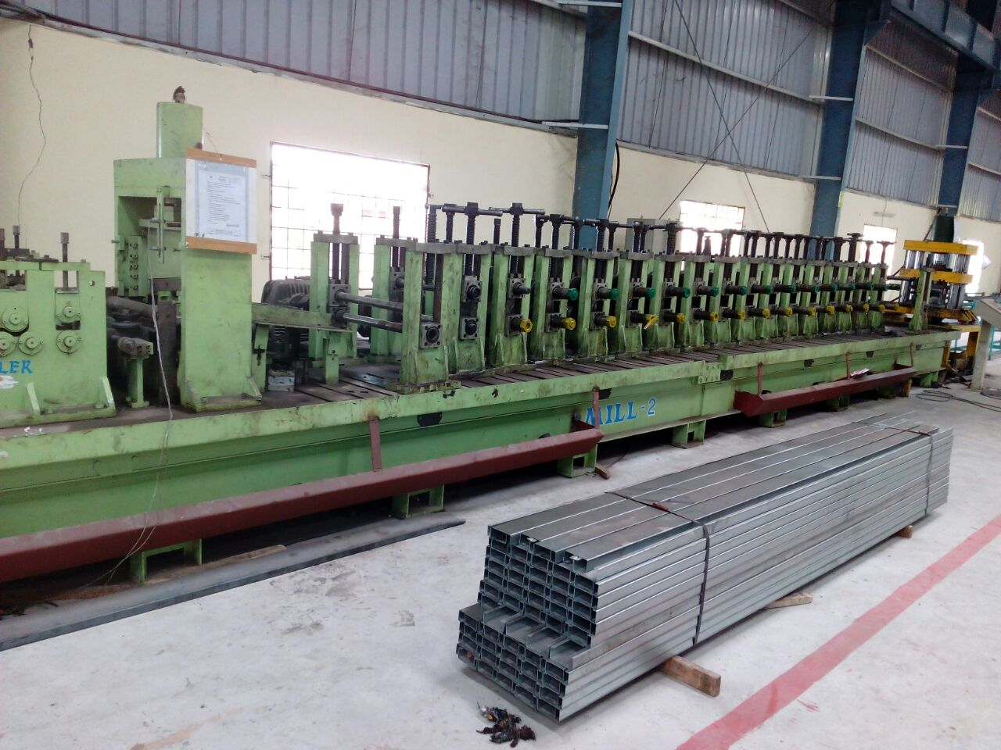

For Techno Machine Tools

(T. Sivaramakrishna)

